**Tagging instructions of association categories types:**

A pair of a cue word, and an association image is presented each time.Please choose the most correct tag that describes each pair, out of these three options:

* **Visually Salient Object**: The cue is one of the main visually salient objects in this specific image.

Do you see the **cue** as an objectin the image? is it clearly visualized in the image, and it is one of the main objects? (If so -> visually salient object)

"Grass" is **visually salient object** in these images:

* **Visually Salient Activity**: The cue is an activity depicted in this specific image.

Do you see the **cue** as an activityin this image? (If so -> visually salient activity)

"Throw" is visually salient activity in this image:

"catch" is visually salient activity in this image:

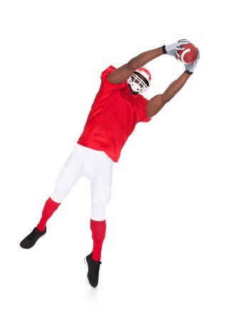

* **Visually Non-Salient**: The cue is related to something visual that is present in this particular image and not necessarily in other images with the same concept. But it is not a visually salient object nor activity (Not **Visually Salient Object**and not **Visual Activity**).

The **cue** is visual but not salient object nor an activity? (If so -> visually non-salient)

"Grass" is visually non-salient in these images:

"Clean" is visually non-salient in this image:

* **Non Visual, Concept Related**: The cue is related to the image concept, not necessarily to this specific image.

Could you understand the **cue** with the **image concept**only? Without seeing the image?   (If so -> non-visual)

"Grass" is non-visual, concept related in these images:

